

Vocabulary

Evergreen, deciduous, mature, disperse, seedling, conditions, stem, leaves, petals, roots, bud, blossom, bark, plant, stalk, bulb germinate, branches, seed

Disperse- plants spread out their seeds so more plants will grow

Brilliant Botanists

**Science**

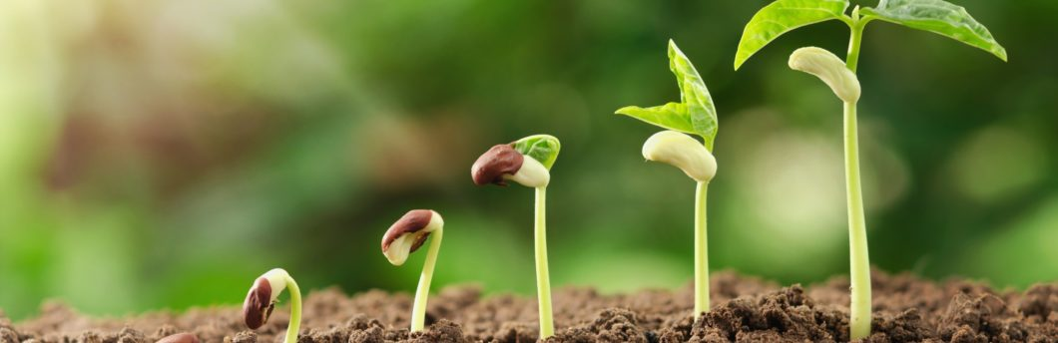

**Mature-** a plant that is fully grown

Different parts of a plant

Conditions for a plant to grow strong and healthy

Water

Air

Light

Heat

Evergreen tree- A tree that keeps its leaves all year. Deciduous- A tree that leaves fall from the branches in colder seasons.