

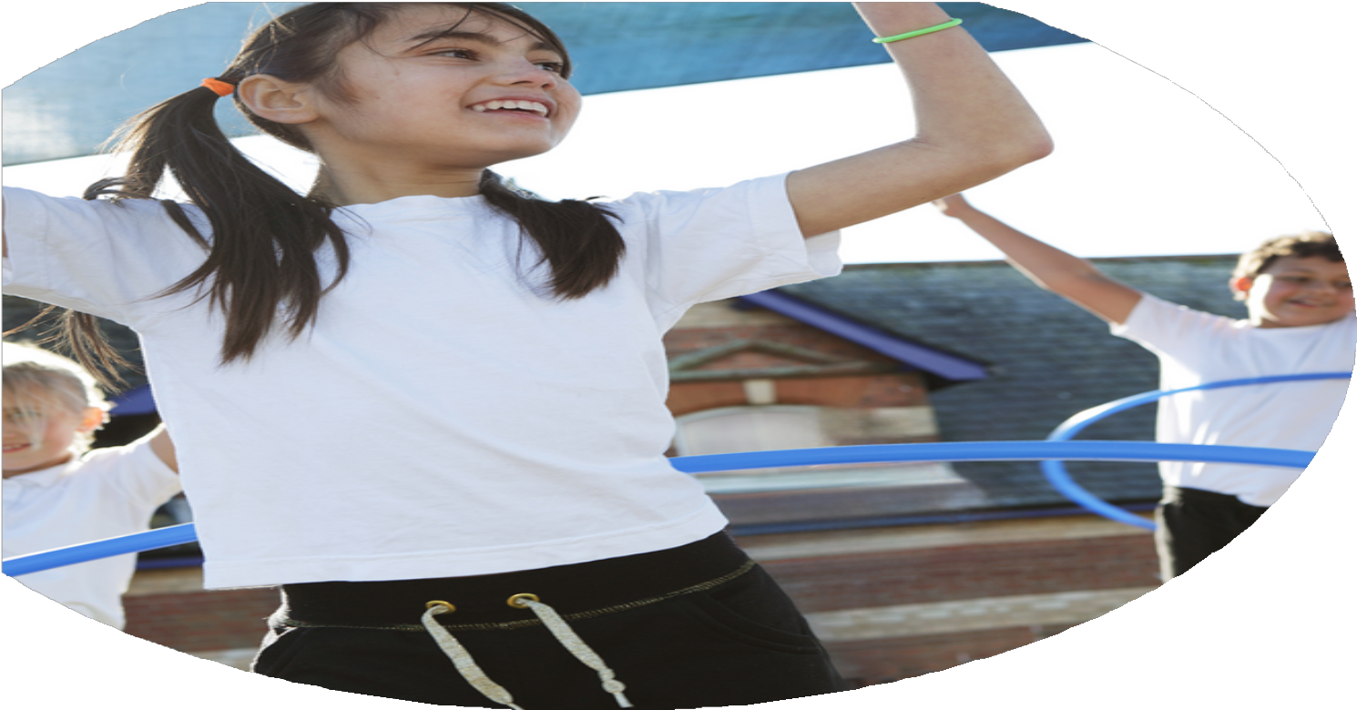





PE Funding

Evaluation Form

Commissioned by

Created by

Images courtesy of Youth Sport Trust

PE Funding Evaluation Form

It is intended that this template should be used as preparation for the completion of the statutory digital reporting tool being introduced this academic year. You can upload data (including swimming) from this template onto this platform once it becomes accessible.
Before you decide how you are going to use the funding for this academic year you should reflect and evaluate the impact of your use of the funding in 2024/25.
All spending of the funding must conform with the terms outlined in the Conditions of Grant document. The template is a working document that you can amend/update during the year.
Based on your evaluation of last year’s funding you should decide what you intend to do this academic year, how you will do it, and what impact you expect it to have.

It is important that the funding is used effectively and based on your school’s needs.
You must use the funding to make additional and sustainable improvements to the PE and sport in your school. You must develop and add to the PESSPA activities that your school already offers.

Summative digital reporting from June 2025 will continue to include swimming and water safety information therefore funding can be used to provide top-up lessons where necessary to ensure pupils meet national curriculum swimming requirements.

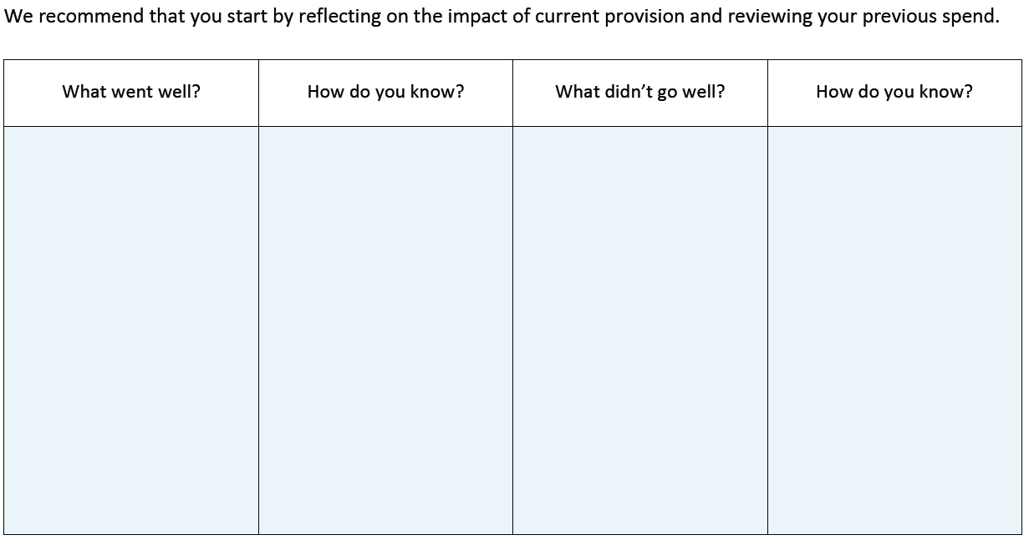
Teachers developed confidence in delivering outdoor learning

Research project underway with Essex research school linked to benefits of outdoor learning. Outdoor learning to be use d regularly to support children who require therapeutic intervention.

To purchase a wide range of outdoor learning equipment to engage all age ranges at Beckers Green to increase enjoyment and engagement.

Staff skills in delivering high quality PE lessons have improved, including confidence levels.

To improve range of clubs available after school and at lunchtime and provide these free of charge to all

Increase attendance at community sporting events and competitions

New playleaders trained and lunchtime activities engage high numbers
\

Teacher feedback.
Nothing

Nothing

High levels of staffing required – but felt this was worth the cost.

Dance continues to be an area where teachers lack confidence

Struggled to engage larger number of disadvantaged children in after school clubs.

Unable to increase attendance due to limited staffing – managed to maintain.

Increased outdoor learning offer available across all year groups and curriculum areas

Research project begun – data collections ongoing

Outdoor learning nurture sessions have utilized new equipment well – meeting range of emotional and physical needs.
Feedback from children very positive.

Feedback from teachers and observations of lessons. New scheme provides quality lesson plans.

Continued with wide range of clubs – including Scottish and Indian dancing, football, rounders, keep fit, running clubs.
With limited staff we continued attendance at range of events across the year.
Observations show excellent engagement with activities.
What are your plans for 2025/26?

Intent
How are you going to action and achieve these plans?

Implementation

School becomes known for excellent outdoor learning offer across range of curriculum areas and to support SEND needs. Active learning encouraged.

Improve quality of Dance lessons.

Children continue to attend range of competitive and community events.

Children have opportunity to engage in increased competitions in school.

Continue free access to after school and lunchtime clubs for all.

Research project on Outdoor learning to be completed. Continued Staff CPD in this area and purchase of resources to ensure outdoor learning areas continue to be used for full range of curriculum offer.

Staff CPD planned in dance.

Transport and staffing costs to enable participation. Membership of local sporting associations.

Purchase of resources to launch interhouse sporting competitions. Staff time to organise and run throughout the year.
Staff paid to run clubs. Coaches employed to run sports clubs. Range of clubs change termly. Attendance tracked and children invited to certain clubs.

What impact/intended impact/sustainability are you
expecting?
How will you know? What evidence do you have or
expect to have?
Monitoring of sessions held outside.
Attendance monitoring and feedback from teachers and pupils. Governors also visit.
Research project data.

Monitoring by PE lead.

Monitoring of attendance.

We are expecting all staff to utilise the outdoor learning areas more regularly and to teach a range of curriculum areas outside. We are hoping this will improve behaviour within class, maybe attendance and encourage children to be active outside.

Staff confidence in delivering high quality dance lessons to increase.

Children experience clubs/sports/activities they have previously not experienced. Numbers of disadvantaged children attending clubs increases.

What impact/sustainability have you seen?
What evidence do you have?

