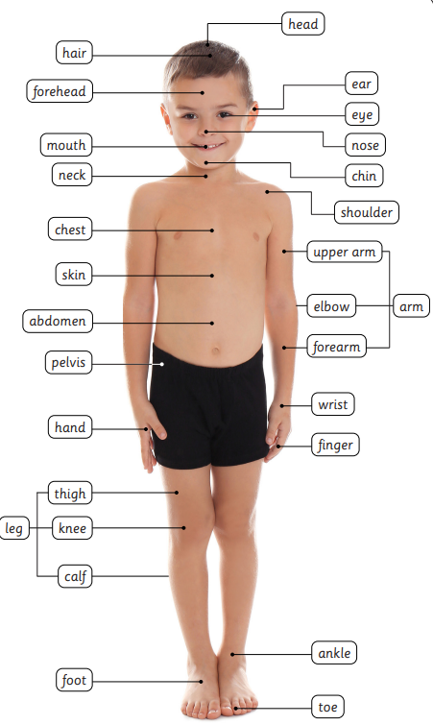
The human body and senses

There are many different parts of the human body. Each body part has a function. For example, our head allows us to sense what is happening around us. Our neck supports and turns the head.
All humans are mammals. Human bodies are generally the same, two arms, two legs etc. Humans vary in size, skin, hair and eye colour…
Our body
Vocabulary
Body | the physical structure, including the bones, flesh, and organs, of a person or an animal.
Five senses | Our 5 senses help us notice the world around us: seeing, hearing, smelling, tasting and touching.

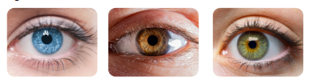
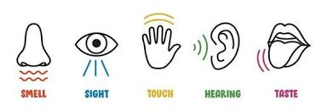
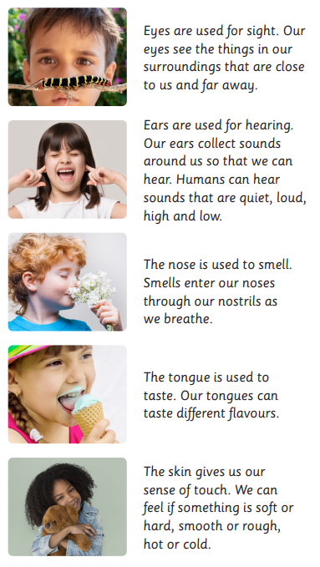
Eyes are used for sight. Our eyes see the things in our surroundings that are close to us and far away. | Ears are used for hearing. Our ears collect sounds around us so that we can hear.  Hearing a fire engine siren warns us to move out of the way. | The nose is used to smell. Smells enter our noses through our nostrils as we breathe.  Smelling rotten food warns us not to eat it so that it does not make us ill. | Sour, sweet, salty, bitter and spicy?  The tongue is used to taste. Our tongues can taste different flavours. | The skin gives us our sense of touch. We can feel if something is soft or hard, smooth or rough, hot or cold.  This is important when it comes to keeping us safe from extremes of temperature.

Our senses
Humans have five senses. We have body parts to allow us to sense our surroundings. Our senses keep us safe. They can warn us if something is wrong and help identify dangers.

