
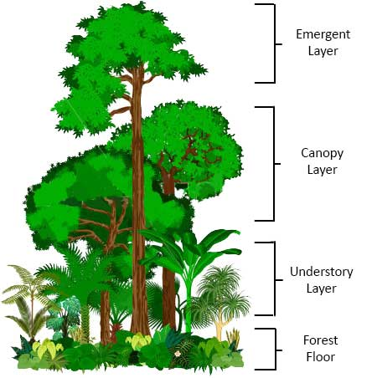

Home to 50% earth animals and plant species
Climate change
Trees suck up the water and without it there will be more flooding.
Trees and plants provide 25% of earths oxygen.
Plants are used in medicines.

Layers - Rainforests have 4 different layers.
Tropical - Region that is frost-free with temperatures high enough to support year-round plant growth.
Humid - High level of water vapour in the atmosphere
Continent - A large mass of land that contains several countries.
Rainfall - Amount of rain that falls in a given area in a certain amount of time
Climate - Long-term weather pattern

Go Wild!

Geography
Why is important to stop cutting down the rainforest?

has the tallest trees.

The Amazon Rainforest has 4 different layers. Each layer is home to different plants, animals, and insects.

Rainforests of the world

The world’s rainforests are found on the equator, where there is a lot of rain, and the sunlight is directly overhead.

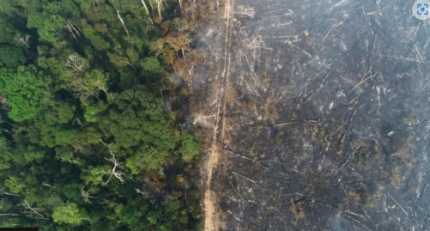
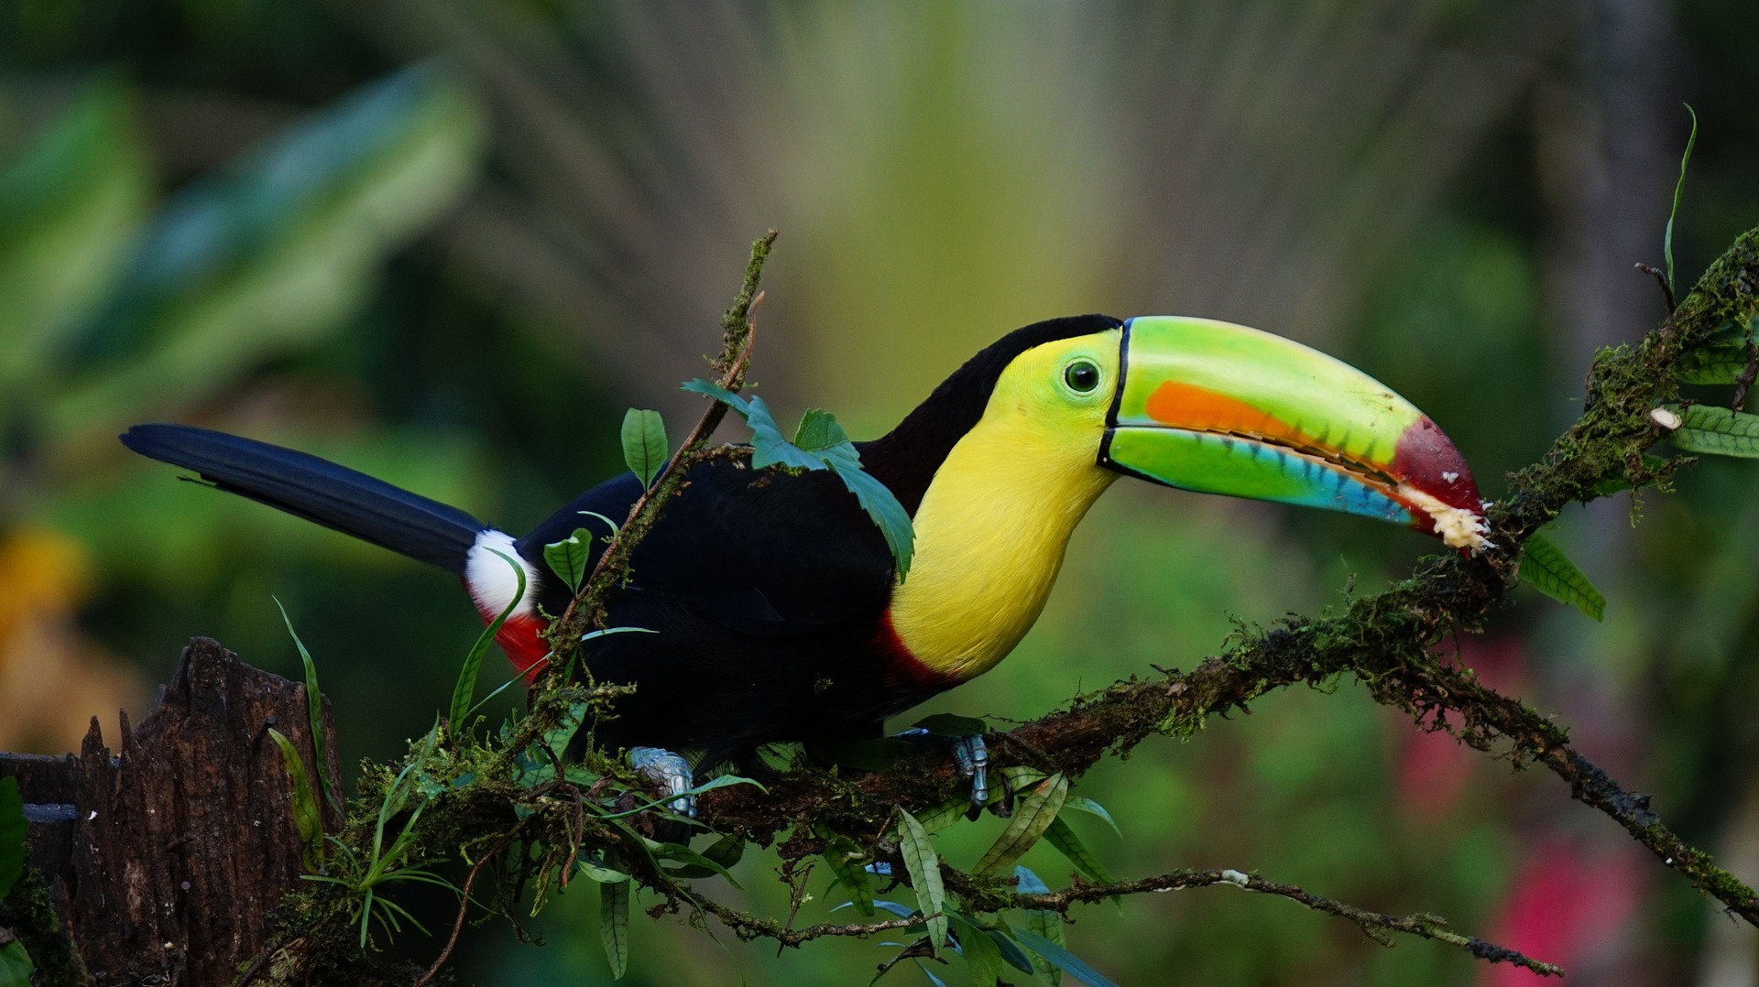
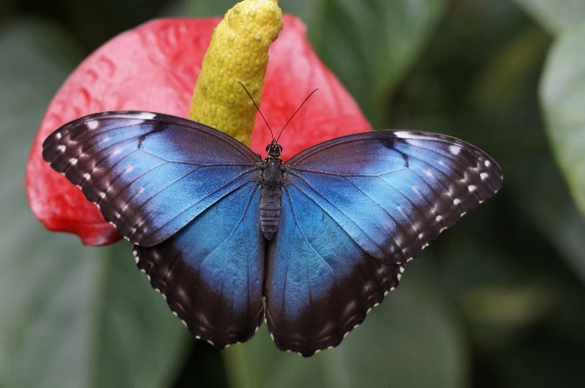
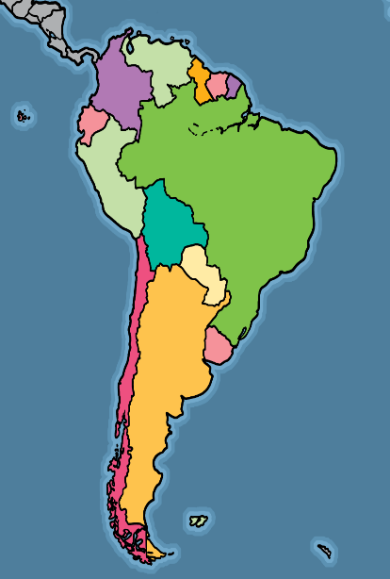
The Amazon rainforest is the largest tropical rainforest. It is found in the continent of South America and spreads across nine countries.

Amazon Rainforest
KEY VOCAB
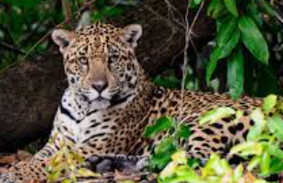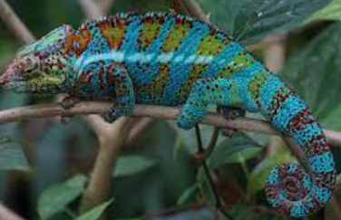
is covered in dead leaves.
is dark and humid.

Is a dense layer.

equator

