Seeds:
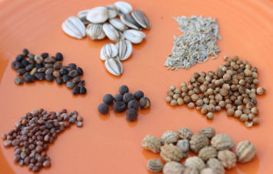

Bulbs:
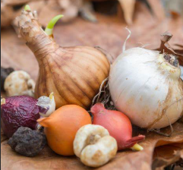
Mature plant:
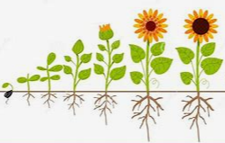

A comparative test enquiry is where we compare one condition with another, for example:

Water and no water
Light and dark

To make these fair, it is important to only test one condition and keep everything else the same to ensure it is a fair test.

Comparative enquiry
Growing seeds and bulbs

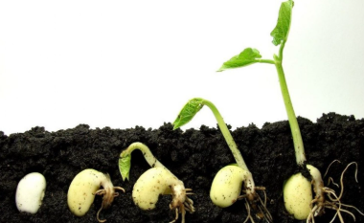
How tall can plants grow?

Does the size of the seed planted affect the size of the mature plant?

No! – a little seed doesn’t always mean a little plant, and a big seed doesn’t always mean a big plant.
Some seeds need light to germinate, whilst others can germinate in darkness. All seeds need water to germinate, oxygen and the correct temperature.
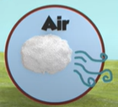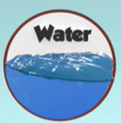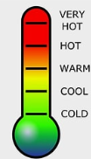
Germination is when seeds or bulbs start to grow.

