
Nurses then and now
Past - Nurses were always women and they were not always trained. People did not respect nurses. Hospitals conditions were busy, dirty and unorganised. They were not safe.
Now - You now have to train to become a nurse and there are lots of different types of nurses in hospitals. Hospitals are safer and have more equipment.

Marvellous Medicine!

History
Sources

Books
Internet
Museums
Photographs
Newspapers
Statues
Florence Nightingale
Florence Nightingale was born in 1820 in Italy. She became a nurse in the Crimean war and helped to look after wounded soldiers.
She was known as
‘The Lady with the
Lamp’ as she checked on soldiers in the night.

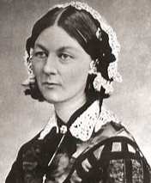

Legacy – remembering these nurses.
Mary Seacole and Florence Nightingale made hospitals better by making changes like washing hands and bedding, fresh air and space, and wards.
There are statues to remember Seacole and Nightingale and their work and we have International Nurses Day on 12th May – Nightingales birthday.

How did these nurses change hospitals?

Vocab

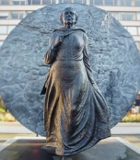
Crimea
Statue
Slave
Hygiene
Typhoid
Cholera
Conditions

Mary Seacole
Mary Seacole was born in 1805 in Jamaica. She was a nurse and wanted to help in the Crimean war but was not allowed as she was black. She went anyway and
helped the soldiers
who were ill and
wounded.



