
Vocabulary
Evergreen, deciduous, mature, disperse, seedling, conditions, stem, leaves, petals, roots, bud, blossom, bark, plant, stalk, bulb germinate, branches, seed

Disperse- plants spread out their seeds so more plants will grow

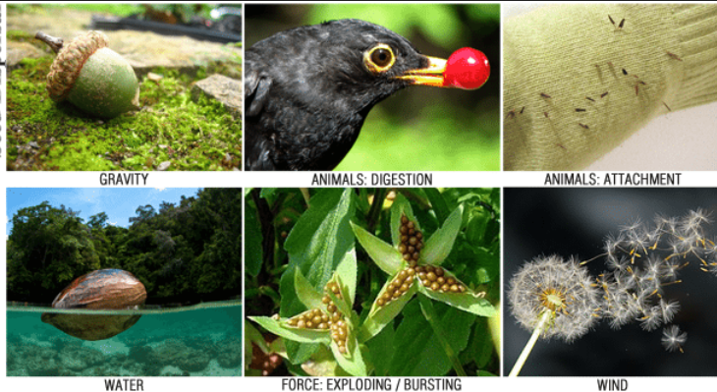

Brilliant Botanists

Science
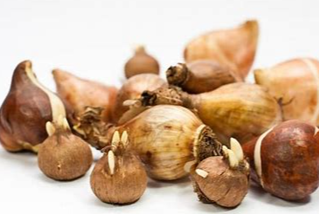
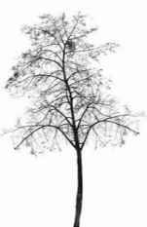
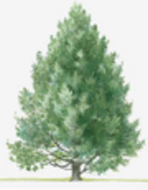
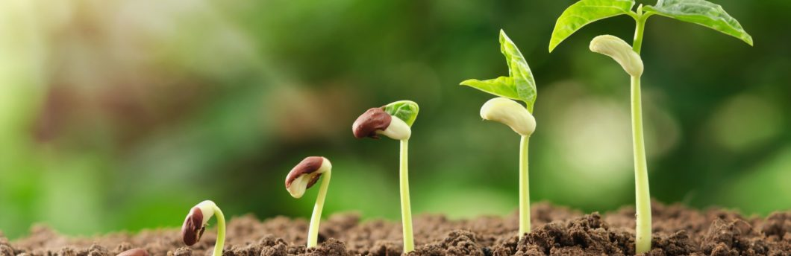
Mature- a plant that is fully grown
Different parts of a plant
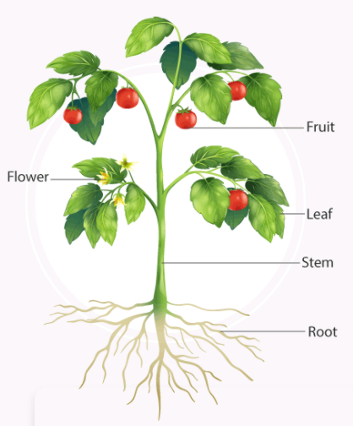

Conditions for a plant to grow strong and healthy

Water
Air
Light
Heat
Evergreen tree- A tree that keeps its leaves all year. Deciduous- A tree that leaves fall from the branches in colder seasons.

