

Who is David Attenborough?
Sir David Frederick Attenborough is an English broadcaster, biologist, natural historian and author.
Born: 8th May 1926.
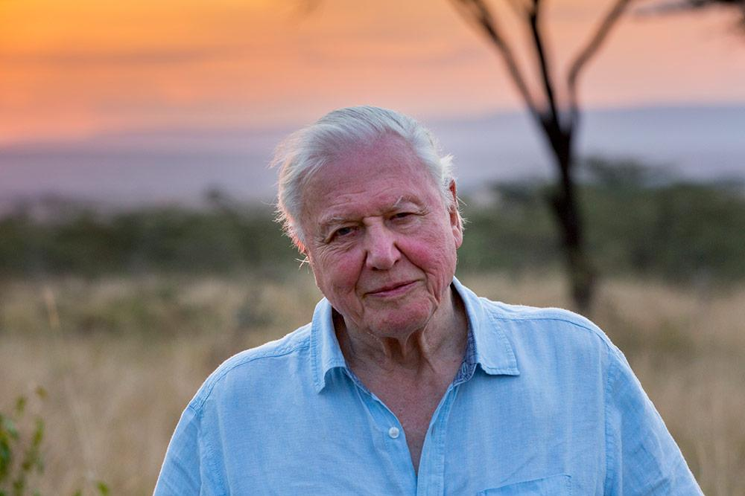
Why is he important?
Sir David Attenborough has inspired millions by bringing the natural world into our homes by making documentaries which people can watch on television.
What is his legacy?
One of the leading voices to defend the natural world and urge action on climate change.

Climate change (or global warming), is the process of our planet heating up. As temperatures rise, some areas will get wetter and lots of animals (and humans!) could find they’re not able to adapt to their changing climate.

What is his legacy?

Sources of evidence.

Who was John Ray?

A botanist who lived in the 17th century.
Born: 29th November 1627
Died: 17 January 1705

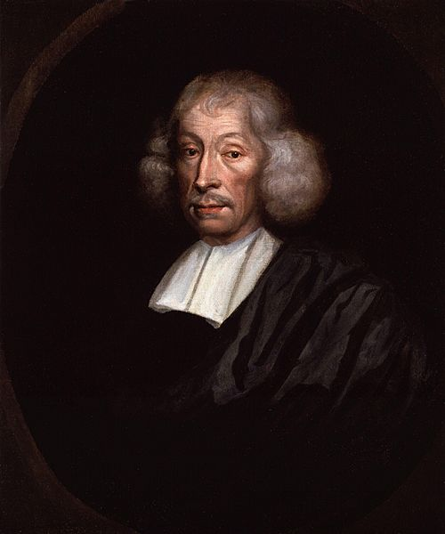
Where did he live?
He was born in Black Notley which is a small village next to Braintree.

Why is he important?
What John Ray discovered helped future scientists.

A botanist is a scientist who studies plants, including flowering plants, and plant-like things such as moss and seaweed.
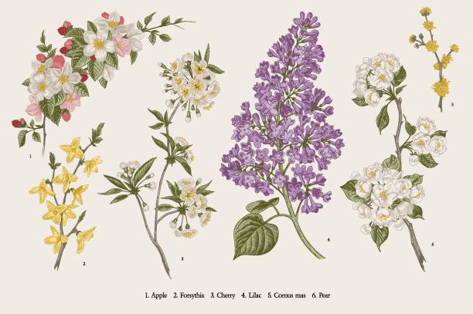

History
Brilliant Botanists
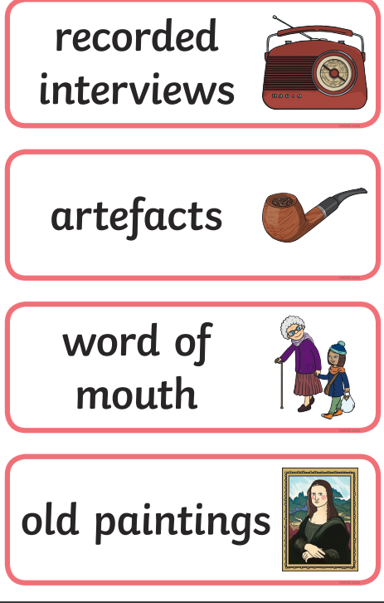
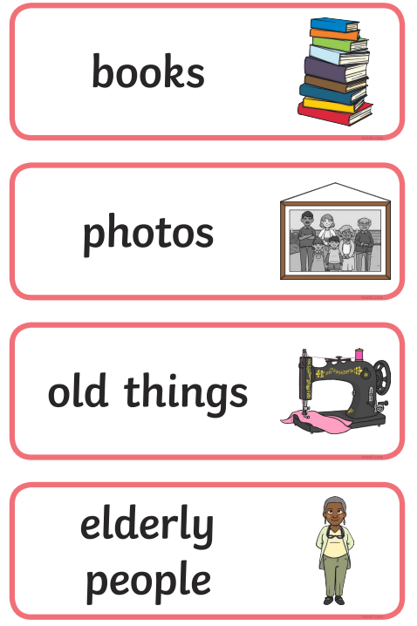
Key Vocabulary: Classify, biology, species, broadcaster, climate change, natural history, naturalist
What is a botanist?
What is climate change?

