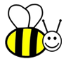
Vocabulary
Habitat, woodland, pond, seashore, suited, omnivore, herbivore, carnivore, camouflage, shelter, living, dead, never been alive, food chain.
Habitat – places where plants and animals live. A habitat can provide food, water, shelter and warmth.

Animals in our local habitats
Woodland Garden
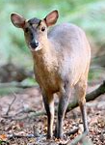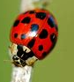
Ponds Seashore
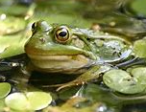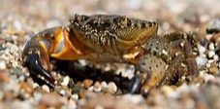

Incredible India

Science
What do we eat?
Carnivore – eats meat.
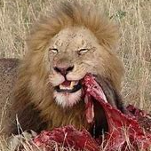
Herbivore – eats plants.
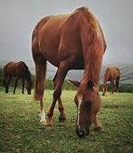
Omnivore – eats meat and plants.
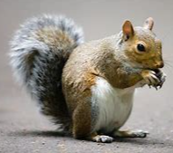

Living – something that is alive, and needs air to survive – humans, animals, plants.
Dead – something that was alive but isn’t now – leaves that have fallen off a tree, bones from an animal.
Never been alive – plastic, rock, metal.

Living, dead or never been alive
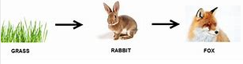
Food chain – how plants and animals get their energy through eating.

