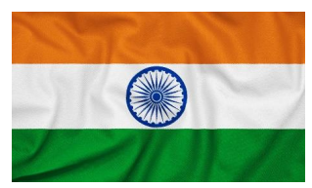

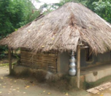

Chembakolli
Physical features
The hills, mountains, rivers, streams, valleys, trees and flowers
Human features
Homes, plantations, farms, roads and pathways; the market; the schools and other buildings.

Human and physical features

Incredible India

Geography
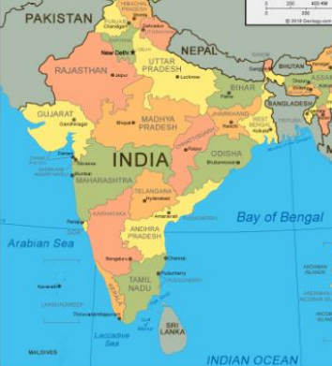


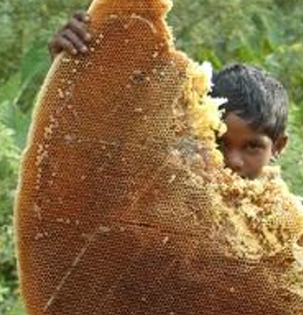


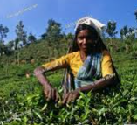
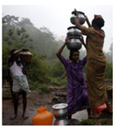
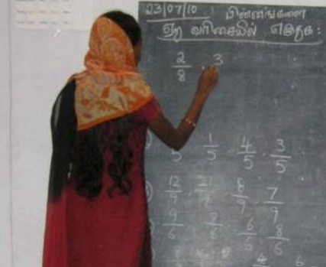
Key Vocab
Hills, mountain, farmers, human, physical, features, India, honey, forest, fair trade, weather, country, plantation.
Adivasi – The tribal people who live and work in the Nilgiri Hills.
Chembakolli, Nilgiri Hills, India
Chembakolli is a small village in Southern India, which is in the continent of Asia.

